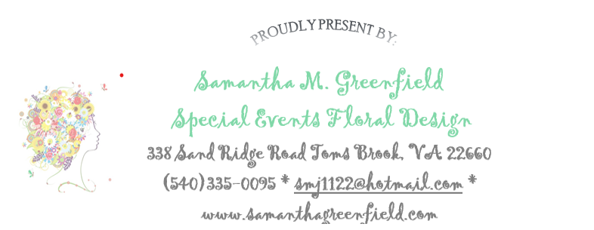
Gold Cup-

May 2, 2026
Floral Pricing
Flower Design Details: Spring garden color palette. (Shades of pinks, peach, apricot, lavender, light blue, yellows, oranges, white/ivory, green). Designer choice flowers for set pricing (below). Special requests or custom orders will require inspiration pictures and pricing will be assessed based on requirements.
Floral selections may include: roses, hydrangea, spray roses, carnations, stock, snap dragons, daisy’s, alstroemeria, baby’s breath, Gerber daisies and other seasonal blooms and filler flowers. Assorted greenery.
Cocktail / High Top Arrangement
- Approx. 3” x 3” airy arrangement in designer choice vessel, unless otherwise requested something specific. If so, pricing will be assessed based on request. Price: $55ea
3' Round Table Arrangement
- Approx. 4” x 4” low compact arrangement in designer choice vessel, unless otherwise requested something specific. If so, pricing will be assessed based on request. Price: $70ea
4’ Round Table Arrangement
- Approx. 5” x 5” Low compact arrangement in designer choice vessel, unless otherwise requested something specific. If so, pricing will be assessed based on request. Price: $90ea
5' Round Table Arrangement
- Medium arrangement in designer choice vessel, unless otherwise requested something specific. If so, pricing will be assessed based on request. Price: $115ea
Small Bar or Buffet Arrangement: this arrangement will be a medium-sized design that will sit directly on table (not elevated) Price: $175ea
Medium Buffet: will be a medium-sized arrangement (elevated yes or no? )Price: $225ea
Large Buffet: Large, elevated arrangement. Riser provided by client (yes or no?) Price: $275ea

